Choice Price AB test result Update as of 2017-10-11 1:45 AM:

As of this Morning, 54 days into the test, the Test Group outperformed the Control Group in Revenue per Visitor,

1. The ATS of the Test Group is significantly higher than that of the Control Group, and the conversion rate of the Test Price Offer has been growing up steadily since the initial dip after the promotion ended on September 5th. The combined effect of the Test Price Offer is generating +6% lift in Revenue per Visitor over the Control Price Offer.
2. We now have strong evidence that the test price offer is generating more revenue than the original price structure. So, we recommend rolling out the new price structure getting partner’s agreement. However, we still have some holdbacks on the fact that 4K costs less than 5K regarding user experience. We can provide further analysis on the exact effect of the price stretch between 4K and 6K to get a better picture.
3. The conversion rate of the Test Group is -8% lower than that of the Control Group
4. The ATS of the Test Group is +15% Higher than that of the Control Group
5. All in all, the Test Group is giving us a +6% lift in Revenue per Visitor over the control Group

You can find the report here, <https://data.points.com/#/views/ChoicePriceTestAug_17/Summary?:iid=1>

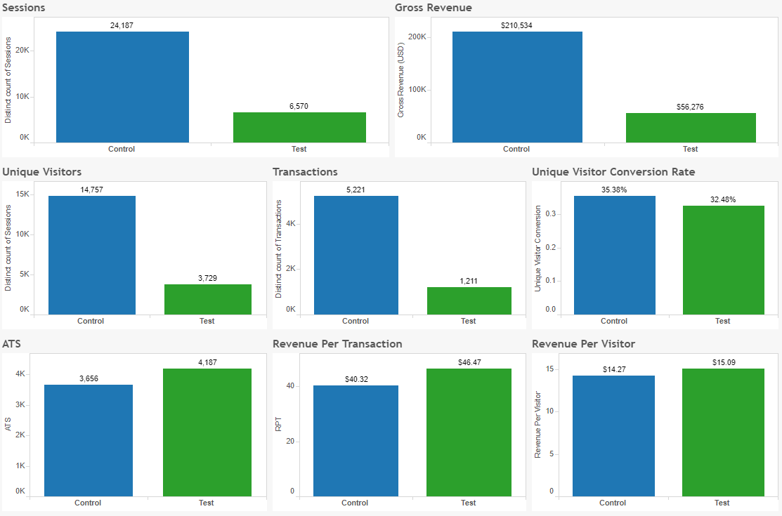

Post Promo

